WIPS CSR ACTIVITY REPORT
- Executive Summary
In alignment with WIPS ER Corporate Social Responsibility (CSR) objectives, WIPS CELL NEEPCO conducted a welfare initiative to support senior citizens residing at Shakti Sedan, a home of distressed women. The activity involved the donation of warm clothing to ensure the comfort and well-being of elderly residents during the winter season. This report outlines the objectives, execution, and impact of the initiative.
- Objectives
- To provide essential winter clothing to elderly residents of the old age home.
- To demonstrate the organization’s commitment to community welfare and social inclusion.
- To encourage employee participation in socially responsible activities.

- Activity Details
- Date of Activity: 23.12.2025
- Location: Umshing, Mawlaimawroh, Shillong
- Items Donated: Sweaters, shawls, blankets, socks, and other warm clothing
- Volunteers: 7 employees from NEEPCO
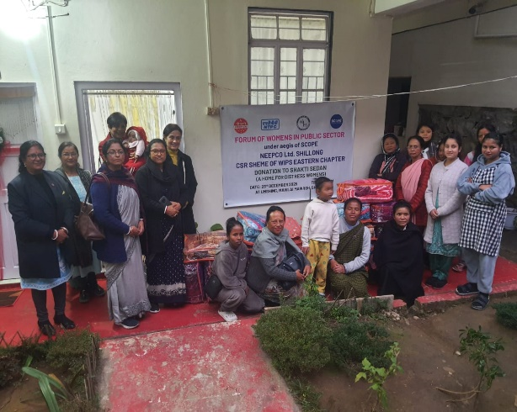
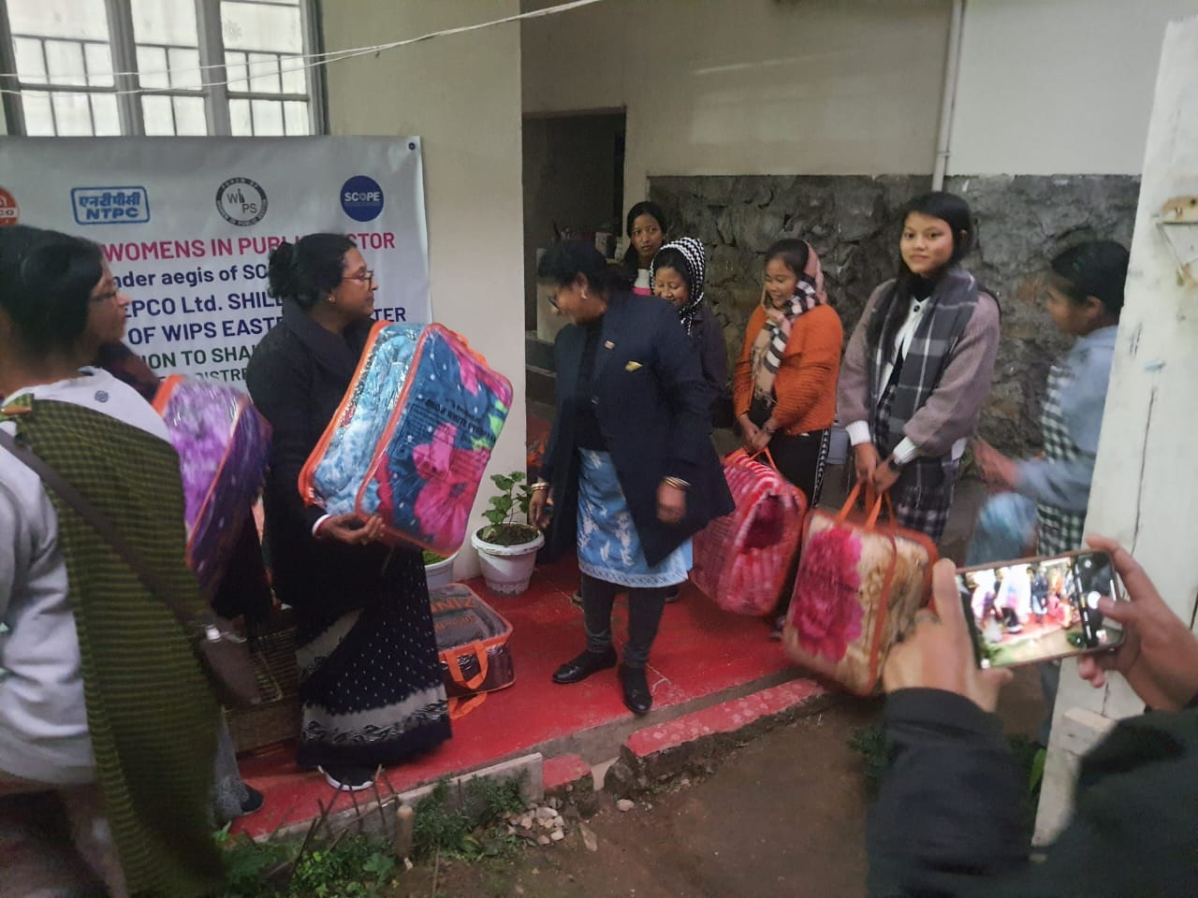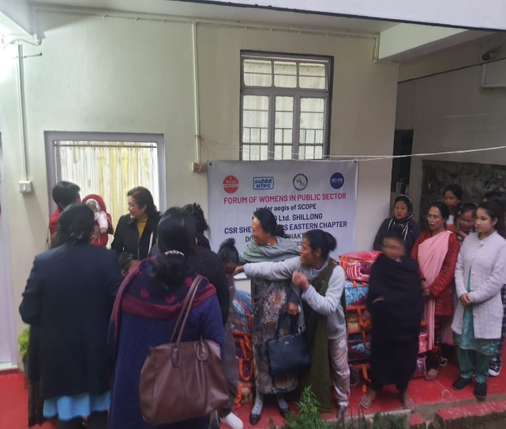
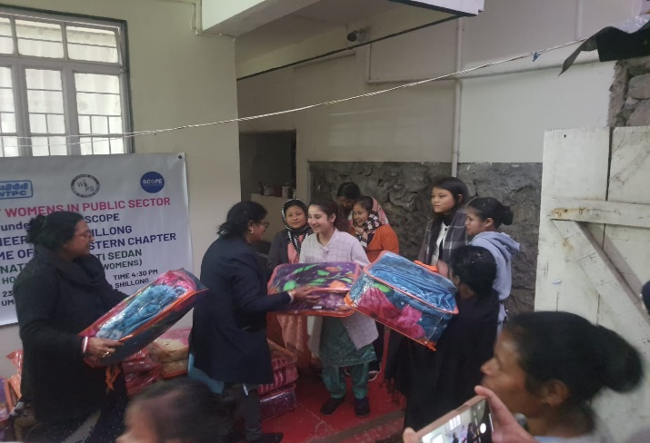

- Implementation Process
- A formal handover ceremony was conducted in the presence of the management and residents of the old age home.
- Employees engaged in an interactive session with the residents, fostering a sense of companionship and care.

- Outcomes and Impact
- Elderly residents received adequate winter clothing, enhancing their comfort and protection against cold weather.
- The initiative strengthened the organization’s relationship with the local community.
- Employee participation reinforced a culture of empathy, volunteerism, and social responsibility within the organization.

- Feedback
The management of the Shakti Sedan, expressed sincere appreciation for the initiative. Residents conveyed their gratitude, highlighting the positive impact of the donation on their daily lives.
- Conclusion
This CSR activity successfully addressed a critical seasonal need while reinforcing our organization’s values of compassion and community engagement. The donation of warm clothes not only provided physical comfort but also conveyed a message of dignity and care to the elderly residents.

